使用STM32F412RET6基于RT-Thread 5.2.2+JHDLCD+LVGL驱动移植

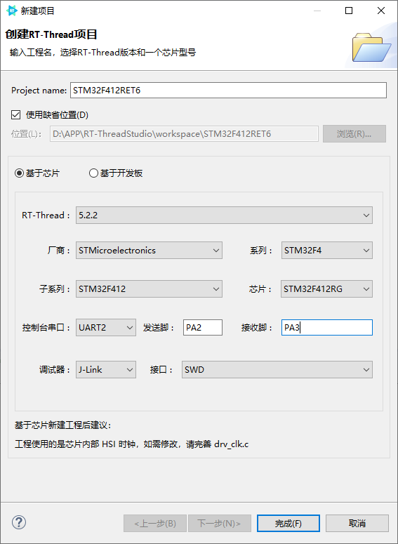
创建工程(已创建跳过)
新建工程
RT-Thread：5.2.2
MCU型号：STM32F412RET6
UART2，TX：PA2；RX：PA3
根据实际硬件电路修改外部晶振
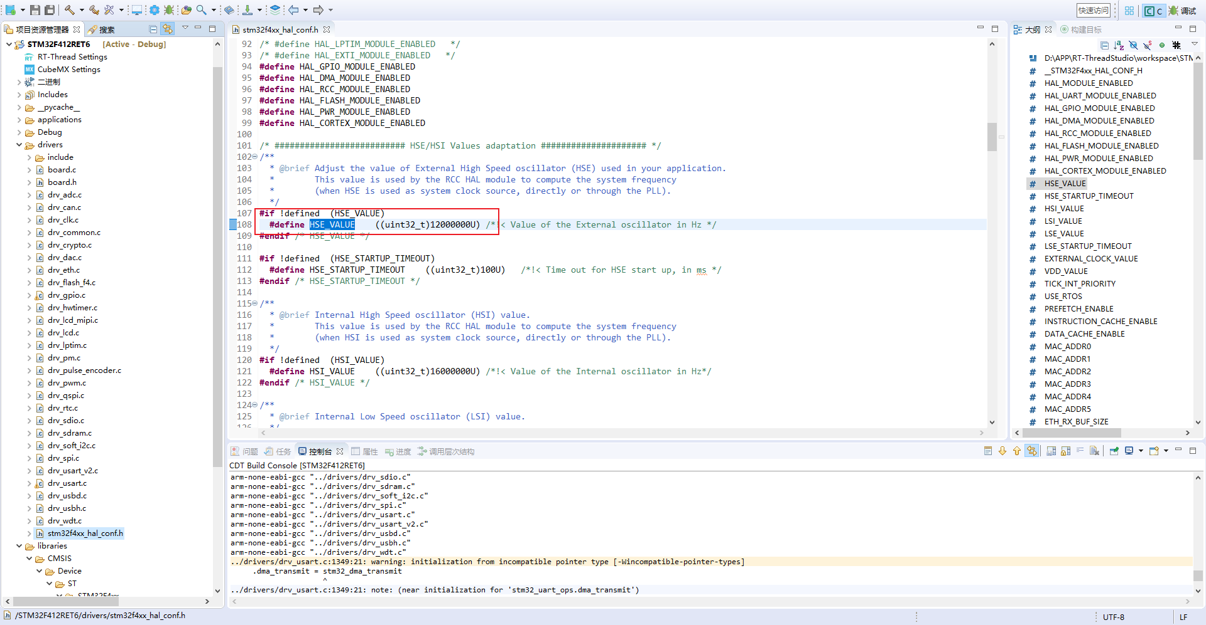
根据实际外部晶振修改系统时钟高配置，可使用STM32CuBeMX工具生成时钟配置代码，并屏蔽原来的时钟配置，建议调整drv_clk打印等级，在运行时可查看系统时钟。
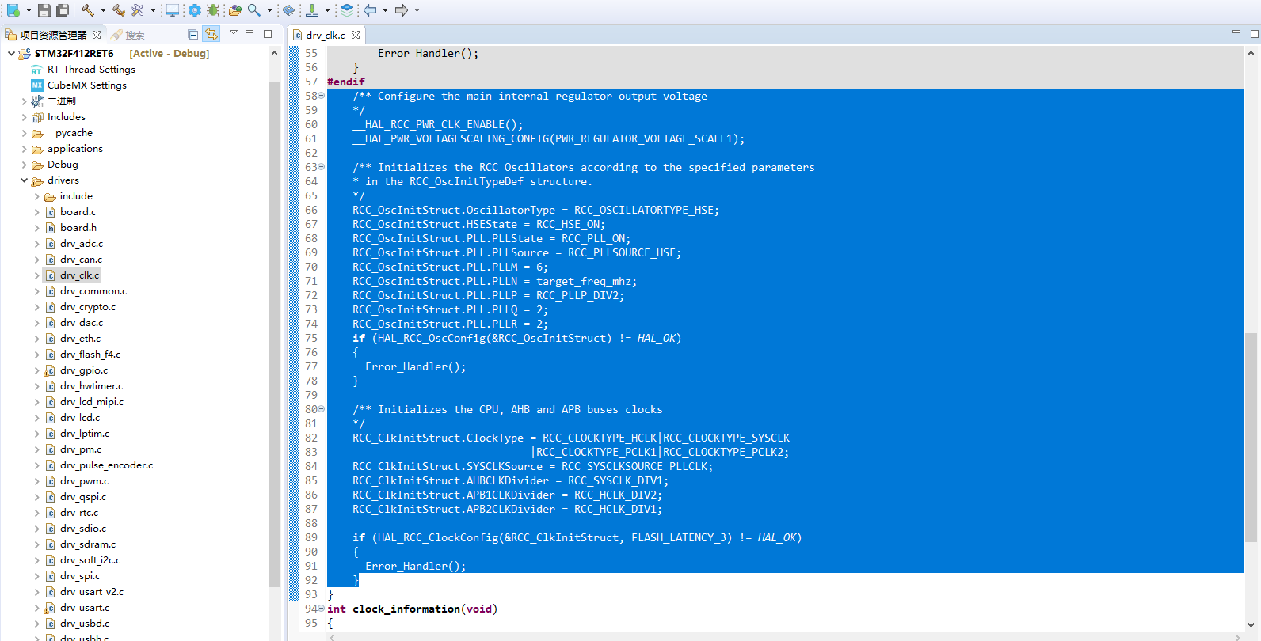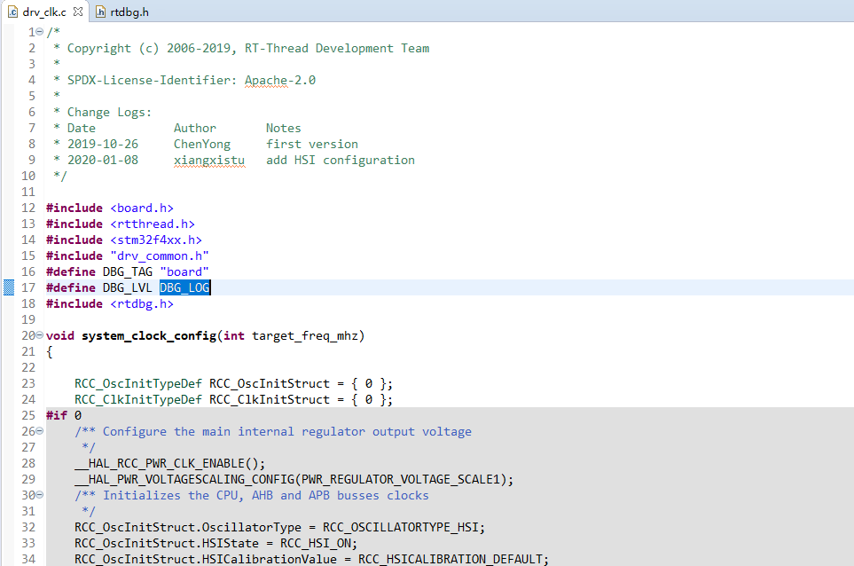
处理工程编译警告（大多数为MCU厂家适配接口与RT-Thread驱动警告，不影响程序运行，少数为RT-Thread源码接口接口，不影响程序运行）

编译、烧写、运行
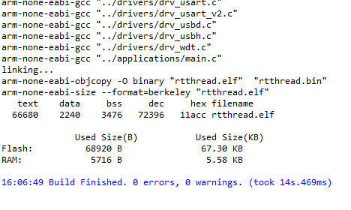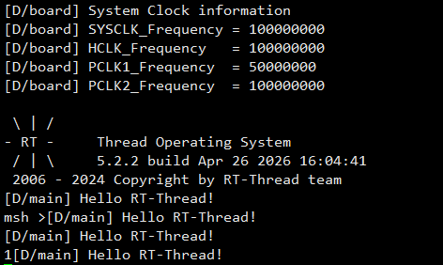

添加JHD LCD驱动(已添加可跳过)
晶彗迪LCD液晶屏，是160*160点阵液晶显示，通过SPI接口实现对液晶屏的显示控制；
按照board.h中按照SPI配置提示，使能SPI
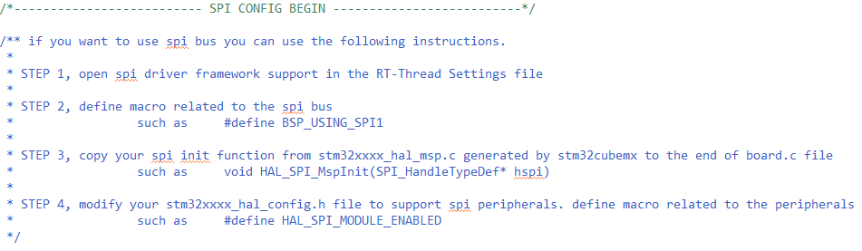
- RT-Thread Setting -> 组件 -> 设备驱动程序 -> 使用SPI总线/设备驱动程序

- 定义BSP_USING_SPI2
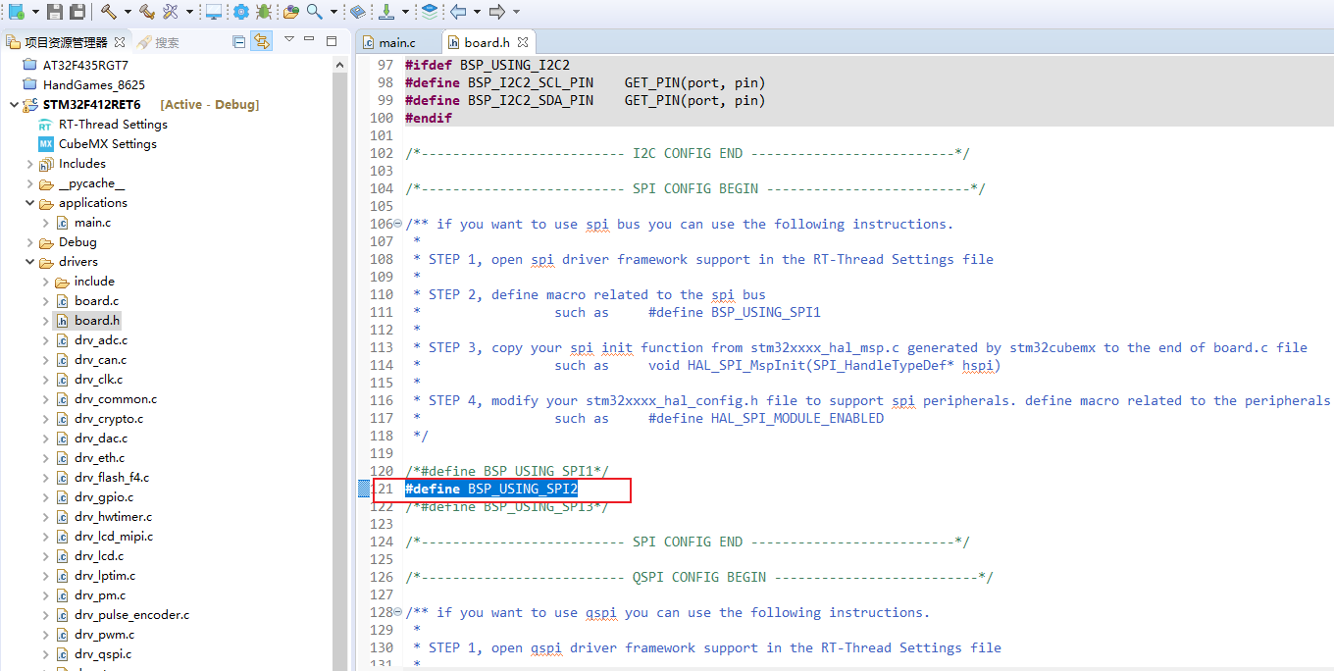
- 移植void HAL_SPI_MspInit(SPI_HandleTypeDef* hspi)函数，可使用STM32CuBeMX工具生成SPI引脚配置。
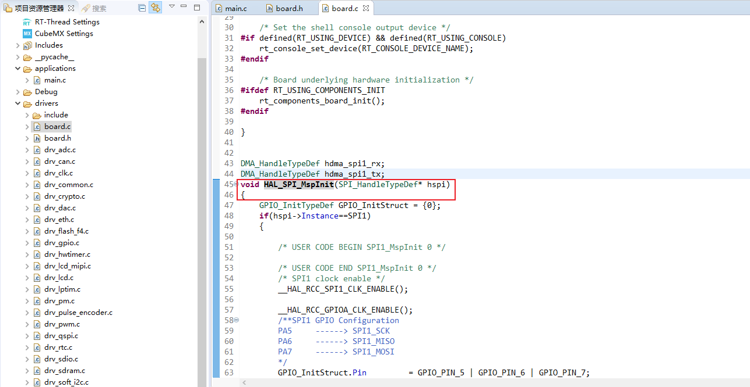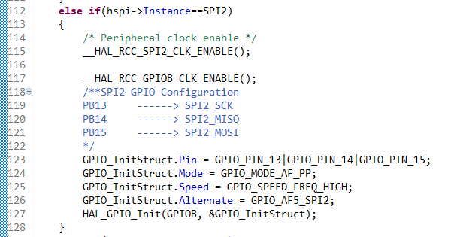
- 在HAL库中定义HAL_SPI_MODULE_ENABLED宏
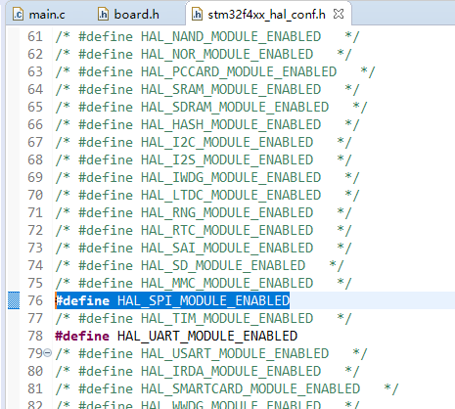
- 移植JHD_LCD驱动代码
drv_JHD_LCD.c
#include "drv_JHD_LCD.h"

#include <drv_common.h>
#include "drv_spi.h"

/* 显示屏 */
#define UC1698u_SPI_NAME "spi2"
#define SPI_UC1698u_DEVICE_NAME "spi21"
#define UC1698u_NSS_GPIO_PORT GPIOC
#define UC1698u_NSS_GPIO_PIN GPIO_PIN_3
#define LCD_NSS_PIN GET_PIN(C, 3)

#define LCD_CD GET_PIN(C, 2) // 数据/指令
#define LCD_CS GET_PIN(C, 3) // 片选
#define LCD_RST GET_PIN(C, 1) // 复位信号

struct rt_spi_device *spi_dev_UC1698u; /* SPI 设备句柄 */

int JHD_LCD_SPI_Init(void)
{
rt_err_t res;

/* 设置片选管脚模式为输出 */
rt_pin_mode(LCD_NSS_PIN, PIN_MODE_OUTPUT);
/* 把spi20挂到spi2上 */
res = rt_hw_spi_device_attach(UC1698u_SPI_NAME, SPI_UC1698u_DEVICE_NAME, UC1698u_NSS_GPIO_PORT, UC1698u_NSS_GPIO_PIN);
if (res == RT_EOK)
{
rt_kprintf("spi2 bus attach LCD device OK !\r\n");
}
spi_dev_UC1698u = (struct rt_spi_device *)rt_device_find(SPI_UC1698u_DEVICE_NAME);
/* config spi */
{
struct rt_spi_configuration cfg;
cfg.data_width = 8;
cfg.mode = RT_SPI_MASTER | RT_SPI_MODE_0 | RT_SPI_MSB;
cfg.max_hz = 20 * 1000 *1000; /* 20M,SPI max 42MHz,ssd1351 4-wire spi */

rt_spi_configure(spi_dev_UC1698u, &cfg);
}

return RT_EOK;

}

void UC1698u_spi_Write(void* data, uint16_t len)
{
// rt_pin_write(LCD_CS, PIN_LOW);
// HAL_SPI_Transmit(&hspi2, data, len, 1000);
rt_spi_send(spi_dev_UC1698u, data, len);
// rt_pin_write(LCD_CS, PIN_HIGH);
}

uint16_t LCD_CD_Pin_Level = 0;
// 低电平命令
void LCD_RS_LOW(void)
{
if(1 == LCD_CD_Pin_Level){
LCD_CD_Pin_Level = 0;
rt_pin_write(LCD_CD, PIN_LOW);
}
}
// 高电平数据
void LCD_RS_HIGH(void)
{
if(0 == LCD_CD_Pin_Level){
LCD_CD_Pin_Level = 1;
rt_pin_write(LCD_CD, PIN_HIGH);
}
}

void LCD_Write_Data(void *Data, uint16_t len)
{
LCD_RS_HIGH(); /* 数据高电平 */
UC1698u_spi_Write(Data, len);
}

void LCD_Write_CMD(uint8_t Cmd)
{
LCD_RS_LOW(); /* 命令低电平 */
UC1698u_spi_Write(&Cmd, 1);
}

void UC1698u_GPIO_Init(void)
{
rt_pin_mode(LCD_CD, PIN_MODE_OUTPUT); // 数据/指令
rt_pin_mode(LCD_CS, PIN_MODE_OUTPUT); // 片选
rt_pin_mode(LCD_RST, PIN_MODE_OUTPUT); // 复位信号

rt_pin_write(LCD_RST, PIN_LOW);
rt_thread_mdelay(10);
rt_pin_write(LCD_RST, PIN_HIGH);

rt_pin_write(LCD_CD, PIN_LOW);
}

void Drv_JHD_LCD_Init(void)
{
UC1698u_GPIO_Init();

JHD_LCD_SPI_Init();
}
drv_JHD_LCD.h
#ifndef APPLICATIONS_JHD_160_160_LCD_DRV_JHD_LCD_H_
#define APPLICATIONS_JHD_160_160_LCD_DRV_JHD_LCD_H_

#include <stdint.h>

void Drv_JHD_LCD_Init(void);
void LCD_Write_Data(void *Data, uint16_t len);
void LCD_Write_CMD(uint8_t Cmd);

#endif /* APPLICATIONS_JHD_160_160_LCD_DRV_JHD_LCD_H_ */
cfg_JHD_LCD.c
#include "cfg_JHD_LCD.h"
#include "drv_JHD_LCD.h"

#include <drv_common.h>

#define GUIXMAX 160
#define GUIYMAX 160

// LCD配置
void cfg_UC1698u(void)
{
LCD_Write_CMD(0xE2); //system reset
rt_thread_mdelay(200);

LCD_Write_CMD(0xeb); //set bias=12 这个需要根据你们具体的bias来更改
LCD_Write_CMD(0x81); //set vop
LCD_Write_CMD(90); //set vop=16.5v（72）, 15.8V（46）16.3V(64)这个参数需要根据你们的VOP来更改
LCD_Write_CMD(0x2b); //set internal pump control

LCD_Write_CMD(0xc4); //set lcd mapping control

LCD_Write_CMD(0x89); //set ram address control //原始数据

//WriteLcdCommand(0xc2); //set lcd mapping control //修改数据
//WriteLcdCommand(0x8d); //set ram address control

LCD_Write_CMD(0x24); // set TC=-0.00%
LCD_Write_CMD(0xa2); // set line rate

LCD_Write_CMD(0xf1); //set com end
LCD_Write_CMD(159);

LCD_Write_CMD(0x85); //set partical display enable
LCD_Write_CMD(0xf2); //set partical display start
LCD_Write_CMD(0);
LCD_Write_CMD(0xf3); //set partical display end
LCD_Write_CMD(159);

LCD_Write_CMD(0x40); //set scorll line
LCD_Write_CMD(0x50); //set scroll line

LCD_Write_CMD(0xd1); //set color pattern
LCD_Write_CMD(0xd5); //set color mode 64k
LCD_Write_CMD(0xC8); //set n-line inversion
LCD_Write_CMD(0x1a);
LCD_Write_CMD(0xd8); //set com scan function

LCD_Write_CMD(0xAD); //set display enable
}

// LCD配置显示窗口
void setWindowsProgame(void)
{

LCD_Write_CMD(0x70); //行地址0
LCD_Write_CMD(0x60);
LCD_Write_CMD(0x12); //列地址35
LCD_Write_CMD(0x03);

LCD_Write_CMD(0xf4);
LCD_Write_CMD(35);//start col 左边界35
LCD_Write_CMD(0xf6);
LCD_Write_CMD(88);//end col 右边界88
LCD_Write_CMD(0xf5);
LCD_Write_CMD(0);//start row 上边界0
LCD_Write_CMD(0xf7);
LCD_Write_CMD(159);//end row 下边界159
LCD_Write_CMD(0xf8); //窗口功能开

}

uint8_t GuiBuff[GUIYMAX][GUIXMAX/2+1];
void GuiUpdateDisplayAll(void)
{
setWindowsProgame();
LCD_Write_Data(GuiBuff, 160*81);

}

void GuiDrawPoint(uint16_t x, uint16_t y, uint16_t color)
{
// if(color == 0){//白色
// GuiBuff[159-y][(159-x) >> 1] &= ~(0x0f << (4*(x%2)));
// }
// else{//黑色
// GuiBuff[159-y][(159-x) >> 1] |= (0x0f << (4*(x%2)));
// }

if(color == 1){//白色
GuiBuff[159-y][(159-x) >> 1] &= ~(0x0f << (4*(x%2)));
}
else{//黑色
GuiBuff[159-y][(159-x) >> 1] |= (0x0f << (4*(x%2)));
}
}

void JHD_LCD_Init(void)
{
Drv_JHD_LCD_Init();

cfg_UC1698u();
}
cfg_JHD_LCD.h
#ifndef APPLICATIONS_JHD_160_160_LCD_CFG_JHD_LCD_H_
#define APPLICATIONS_JHD_160_160_LCD_CFG_JHD_LCD_H_

void JHD_LCD_Init(void);

#endif /* APPLICATIONS_JHD_160_160_LCD_CFG_JHD_LCD_H_ */
在main.c中调用JHD_LCD_Init()初始化函数，即可初始化LCD，编译、下载、运行
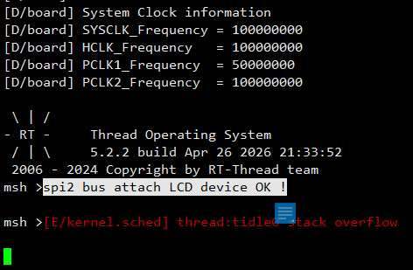
，打印信息提示spi2初始化成功，回车程序崩溃
需调整空闲线程栈大小，可以调整为512Byte，
调整后重新编译、下载、运行。执行list device
查看SPI设备块，即表示SPI初始化成功，LCD
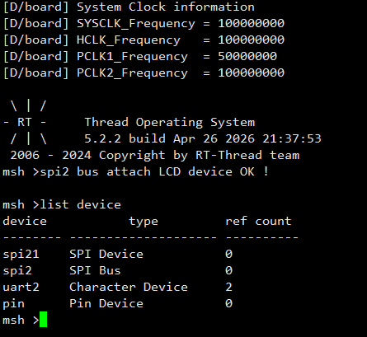
顺利跑起来，可根据GuiUpdateDisplayAll()函数和
GuiDrawPoint()测试绘制界面功能

添加LVGL软件包
- 添加LVGL软件包
RT-Thread Settings-> 添加软件包 ->

- 添加LCD驱动程序到LVGL
复制lv_port_disp_template.c/lv_port_disp_template.h/lv_port_indev_template.c/lv_port_indev_template.h四个文件到工程
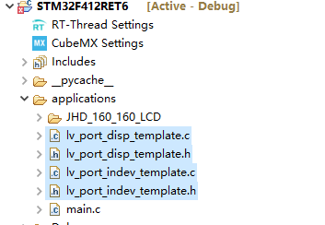
四个文件在一下路径中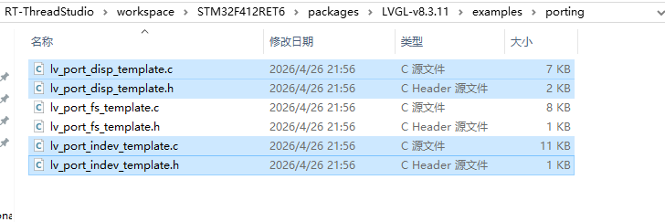
在lv_port_disp_template.c修改#if 为1，并定义LCD大小为160 *160
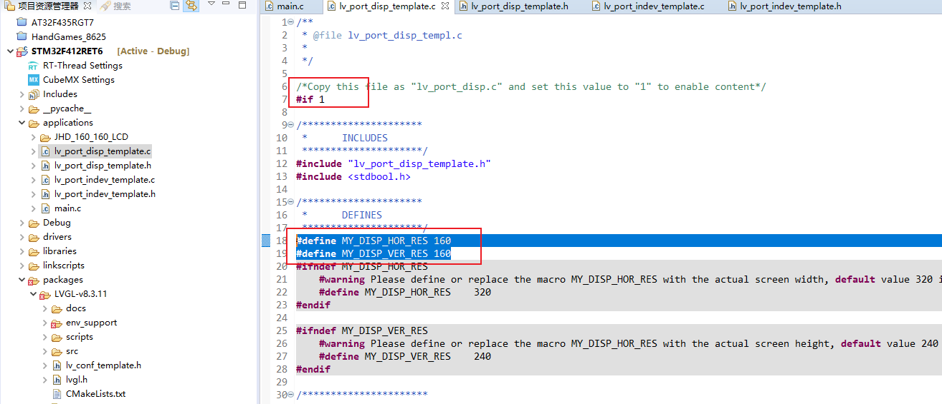

在lv_port_disp_init函数中取消Example for 2)和Example for 3)
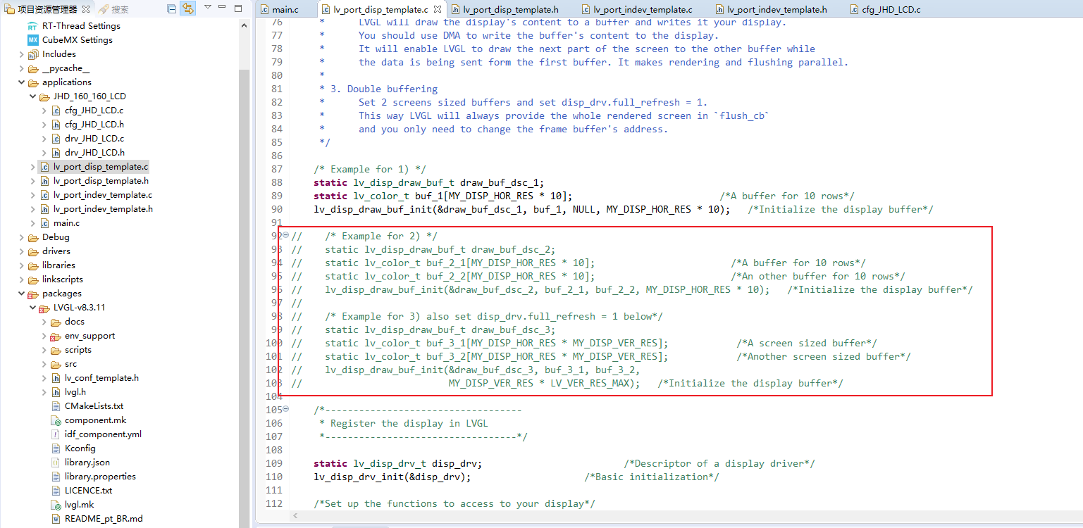
在disp_init函数中添加LCD初始化函数
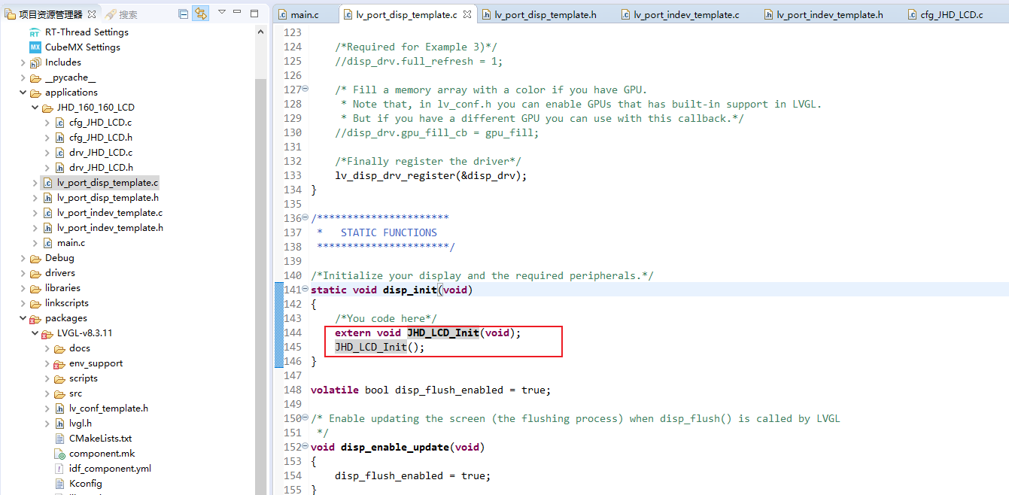
在disp_flush函数中增加LCD画点函数，并增加显示画面函数
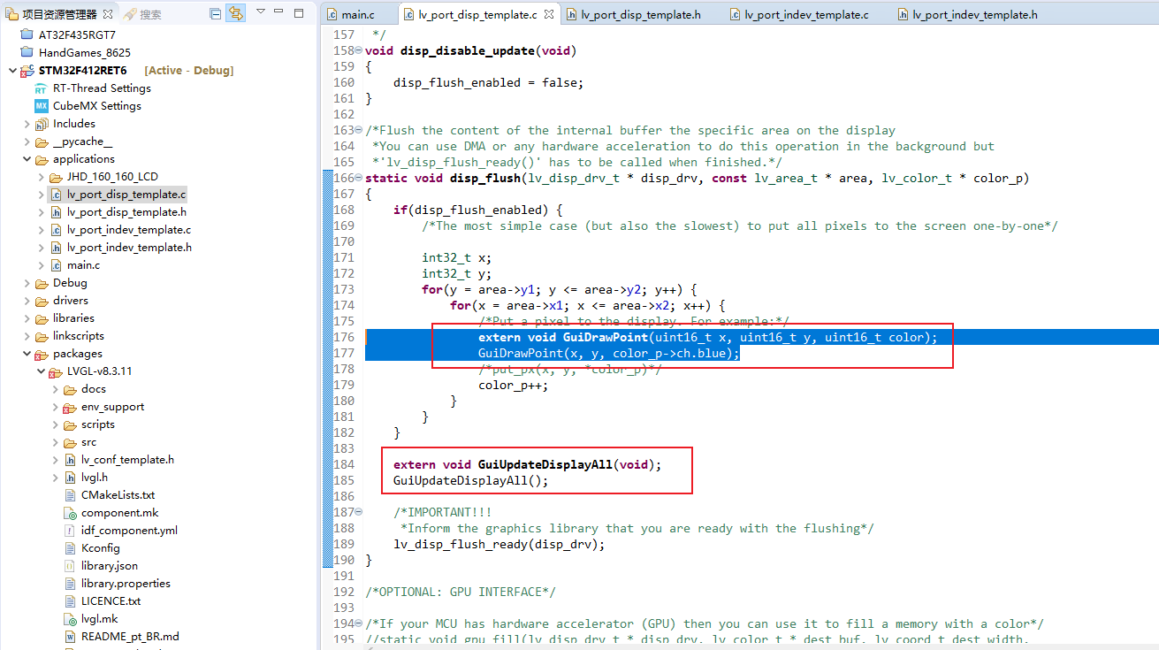
找到disp_flush()最后一个参数变量类型lv_color_t，找到其定义，找到其定义下的LV_COLOR_DEPTH宏定义，修改其值为1。
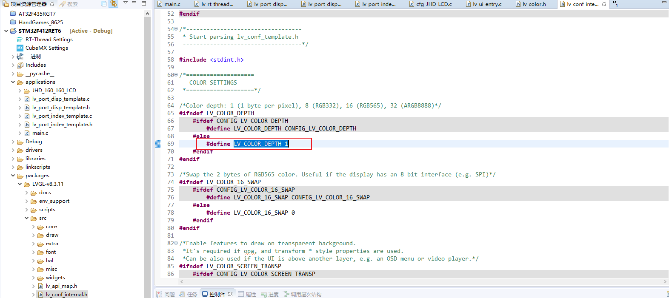
在packages->env-support->rt-thread->lv_rt_thread_port.c中lvgl_thread_entry线程，屏蔽lv_port_indev_init函数，这是输入函数，用于触摸输入
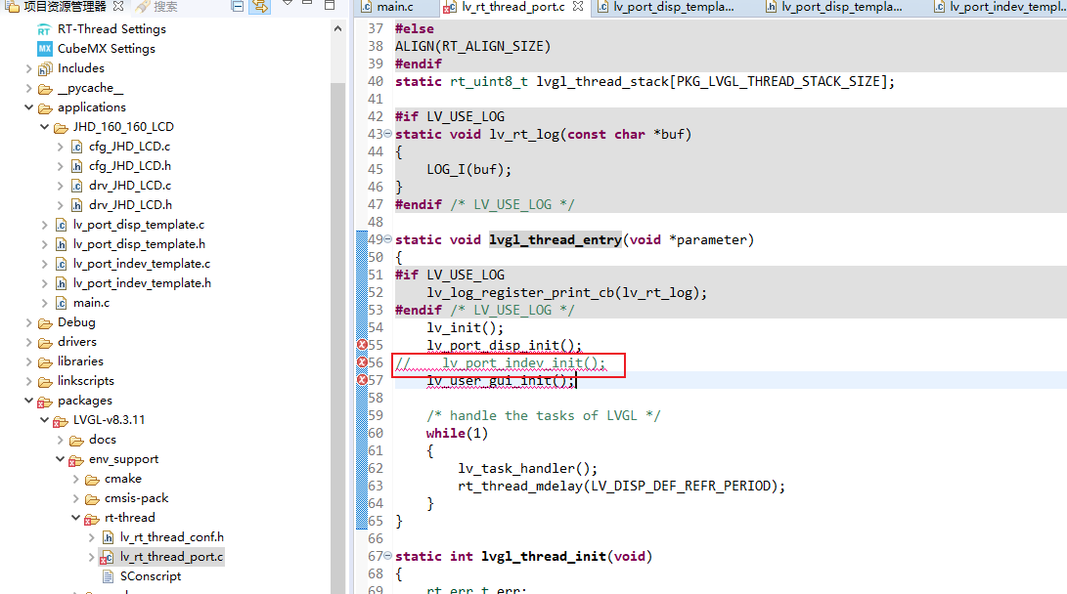
在mian.c中添加lv_user_gui_init()函数
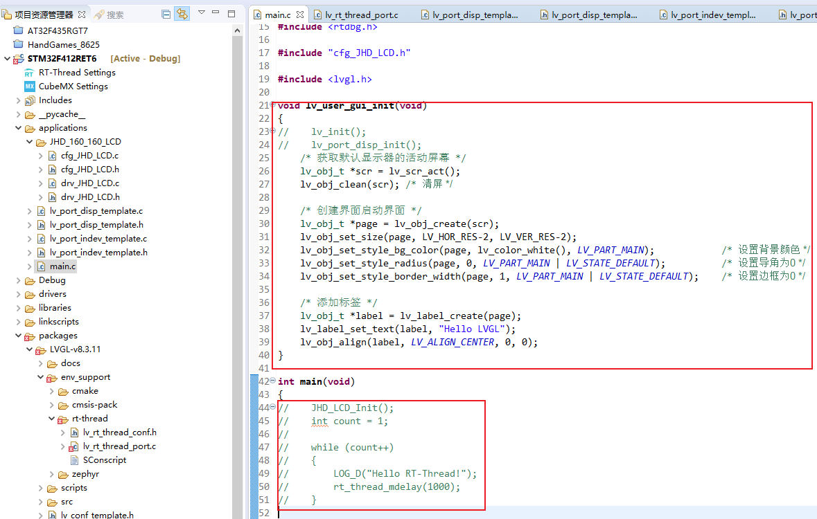
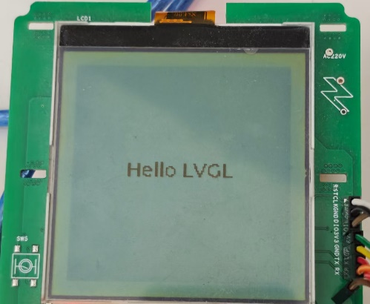
编译、下载、运行

